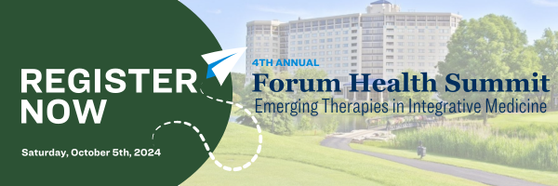
Subject line: You’re Invited! Forum Health Summit
Preheader text: Join us on Saturday, October 5th
Hello!
We’re excited to announce our participation at the 4th Annual Forum Health Summit: Emerging Therapies in Integrative Medicine on Saturday, October 5th in Oakbrook, IL.
The brightest minds in functional and integrative medicine will converge to explore the latest advancements in healthcare, connect with industry leaders, and discover cutting-edge solutions that will shape the future of healthcare.
COMPANY NAME is proud to be an exclusive vendor for this prestigious conference and we want to see YOU there!
[Register for the Forum Health Summit]
This year's event promises to be an unforgettable experience, featuring keynote speaker Dr. Dale Bredesen, renowned for his groundbreaking work in neurodegenerative diseases; and featured experts Dr. Sahar Swidan, Dr. Paul Anderson and Dr. Thomas G. Guilliams. Additional speakers to be announced, here.
Join us at this premier event to shape the future of healthcare, together.
[Secure Your Spot Now]
We look forward to seeing you at the Forum Health Summit!
ADD SIGNATURE

